Environmental Protection Monitoring Data | Air Emissions
Period | 2016 Testing
PPG Environmental Protection License | 1996
PPG License on the EPA Website | Link Here
Site Address | 9 Birmingham Avenue Villawood NSW 2163
Postal Address | PO Box 204 Chester Hill NSW 2162
Australian Head Office | 14 McNAUGHTON Rd CLAYTON VIC 3168  PH (03) 92634942

2 Limit Conditions
L2 Load limits
L2.1 The actual load of an assessable pollutant discharged from the premises during the reporting period must not exceed the load limit specified for the assessable pollutant in the table below.
L2.2 The actual load of an assessable pollutant must be calculated in accordance with the relevant load calculation protocol.
Assessable Pollutant | Load limit (kg)
Benzene (Air)
Fine Particulates (Air) | 161.00
Nitrogen Oxides - Summer (Air)
Nitrogen Oxides (Air)
Volatile organic compounds - Summer  (Air) | 7850.00
Volatile organic compounds (Air) | 35000.00

4 Monitoring and Recording Conditions
M2 Testing methods - load limits
Note: Division 3 of the Protection of the Environment Operations (General) Regulation 2009 requires that monitoring of actual loads of assessable pollutants listed in L2.2 must be carried out in accordance with the relevant load calculation protocol set out for the fee-based activity classification listed in the Administrative Conditions of this licence.

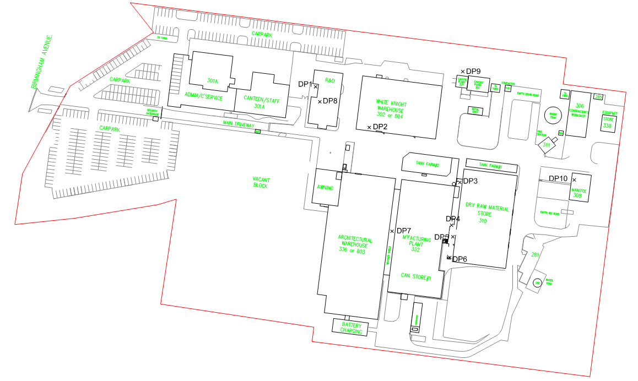
Figure 1: Sampling Locations
DP = Discharge Point

DP3 - Bulk Bag Stack
Date | 15/09/16
Report | R003394
Stack ID | DP3 - Bulk Bag Stack
Sampling Plane Details
Sampling plane dimensions | 730 x 355 mm
Sampling plane area | 0.259 m²
Sampling port size, number & depth | 4" BSP (x1)
Duct orientation & shape | Vertical | Rectangular
Downstream disturbance | Exit | 1.5 D
Upstream disturbance | Bend | 0.5 D
No. traverses & points sampled | 1 | 3
Stack Parameters  Moisture content, %v/v  Gas molecular weight, g/g mole Gas density at STP, kg/m³ | 1.1  28.8 (wet)  1.29 (wet) |  | 29.0 (dry)  1.29 (dry)
Gas Flow Parameters |  | Results  PM 10
Measurement time (hhmm) |  | 0941
Temperature, °C |  | 18
Temperature, K |  | 291
Velocity at sampling plane, m/s |  | 14
Volumetric flow rate, discharge, m³/s |  | 3.6
Volumetric flow rate (wet STP), m³/s |  | 3.4
Volumetric flow rate (dry STP), m³/s |  | 3.4
Mass flow rate (wet basis), kg/hour |  | 16000
Sampling time, min |  | 60
Isokinetic rate, % |  | 104
Isokinetic | Results
Sampling time | 0945-1045 (PM10)
 | Concentration | Mass Rate
 | mg/m³ | g/min
Particulate matter <10µm | <3 | <0.6
50 cut size, 10µm | 10.4

DP5 - Bag Splitter & MBM Exhaust Outlet
Date | 15/09/15
Report | R003394
Stack ID | DP5 - Bag Splitter & MBM Exhaust Outlet
Sampling Plane Details
Sampling plane dimensions | 610 x 420 mm
Sampling plane area | 0.256 m²
Sampling port size, number & depth | 4" BSP (x2)
Duct orientation & shape | Vertical | Rectangular
Downstream disturbance | Exit | 0.8 D
Upstream disturbance | Bend | 1 D
No. traverses & points sampled | 2 | 6
Stack Parameters  Moisture content, %v/v  Gas molecular weight, g/g mole Gas density at STP, kg/m³ | 28.8 (wet)  1.29 (wet) | 1.3 | 29.0 (dry)  1.29 (dry)
Gas Flow Parameters |  | Results  PM 10
Measurement time (hhmm) |  | 1052
Temperature, °C |  | 18
Temperature, K |  | 291
Velocity at sampling plane, m/s |  | 13
Volumetric flow rate, discharge, m³/s |  | 3.4
Volumetric flow rate (wet STP), m³/s |  | 3.2
Volumetric flow rate (dry STP), m³/s |  | 3.1
Mass flow rate (wet basis), kg/hour |  | 15000
Sampling time, min |  | 60
Isokinetic rate, % |  | 100
Isokinetic | Results
Sampling time | 1055-1155 (PM10)
 | Concentration | Mass Rate
 | mg/m³ | g/min
Particulate matter <10µm | <3 | <0.6
50 cut size, 10µm | 9.3

DP6 - Laneway Baghouse Dust Extractor
Date | 15/09/15
Report | R003394
Stack ID | DP6 - Laneway Baghouse Dust Extractor
Sampling Plane Details
Sampling plane dimensions | 600 x 450 mm
Sampling plane area | 0.27 m²
Sampling port size, number & depth | 4" BSP (x2)
Duct orientation & shape | Vertical | Rectangular
Downstream disturbance | Exit | 3.5 D
Upstream disturbance | Bend | 2 D
No. traverses & points sampled | 2 | 6
Stack Parameters  Moisture content, %v/v  Gas molecular weight, g/g mole Gas density at STP, kg/m³ | 1.3  28.8 (wet)  1.29 (wet) |  | 29.0 (dry)  1.29 (dry)
Gas Flow Parameters |  | Results  PM 10
Measurement time (hhmm) |  | 1201
Temperature, °C |  | 17
Temperature, K |  | 290
Velocity at sampling plane, m/s |  | 14
Volumetric flow rate, discharge, m³/s |  | 3.7
Volumetric flow rate (wet STP), m³/s |  | 3.5
Volumetric flow rate (dry STP), m³/s |  | 3.5
Mass flow rate (wet basis), kg/hour |  | 16000
Sampling time, min |  | 60
Isokinetic rate, % |  | 86
Isokinetic | Results
Sampling time | 1205-1307 (PM10)
 | Concentration | Mass Rate
 | mg/m³ | g/min
Particulate matter <10µm | <3 | <0.6
50 cut size, 10µm | 10

